ST. JOSEPH’S S.S.S BUTENGA
END OF TERM 2 EXAMINATIONS 2023
PHYSICS S.2

2 Hours 15 Minutes

INSTRUCTIONS TO LEARNERS
• Answer all questions.
• Show all you’re working.
• All answers should be written in the spaces provided.

1. Mr. owiny and Mr.ochen had an argument over the width of the path that separates their
land. Mr. owiny claimed that the path is 12 feet wide. However, Mr.Ochen claimed it was 10 feet. When the chairman intervened, he measured the path with a foot rule and found out that it was 8 feet, after that the three were in disagreement.
a) Why did Mr. Owiny and Mr.Ochen fail to agree on the width of their path? (01mark)
………………………………………………………………………………………………………………………
………………………………………………………………………………………………………………………
………………………………………………………………………………..............................................

b) Why do you think the chairman got a different measurement? (01mark)
………………………………………………………………………………………………………………………
……………………………………………………………………………………………………………………... c) As a physics learner, how would you solve the disagreement? (02marks)
………………………………………………………………………………………………………………………
………………………………………………………………………………………………………………………
2. Complete the table below
 | Physical quantity | S.I unit | symbol
1.  2.  3. | Mass  …………………………..  Length | …………………………….  Seconds  ……………………………. | Kg  …………………………………  …………………………………

3. A book of 32 pages is bound with sheets of paper each of thickness 0.20mm and two
covers each of thickness 0.50mm.What is the thickness of the book in. (04 marks)
i) mm
………………………………………………………………………………………………………………………
………………………………………………………………………………………………………………………
………………………………………………………………………………………………………………………
………………………………………………………………………………………………………………………
ii) m
………………………………………………………………………………………………………………………
………………………………………………………………………………………………………………………
………………………………………………………………………………………………………………………
………………………………………………………………………………………………………………………

4. The table below shows some of the physical properties of mercury, alcohol and water.
 | FP(0) | BP(0) | Color | Contact with  glass | Heat conduction | Expansion
Mercury | -39 | 357 | Silver | Does not wet glass | Good conductor | Expand uniformly
Alcohol | -115 | 78 | Colorless | Wets glass | Poor conductor | Expand uniformly
Water | 0 | 100 | colorless | Wets glass | Poor conductor | Not uniform
Use the information from the table and answer the following questions.
a) What are the advantages of mercury over alcohol as a thermometric liquid? (02marks)
………………………………………………………………………………………………………………………
………………………………………………………………………………………………………………………
………………………………………………………………………………………………………………………
b) Why is water not used as a thermometric liquid? (02marks)
………………………………………………………………………………………………………………………
………………………………………………………………………………………………………………………
………………………………………………………………………………………………………………………
5) (a) What do we use to measure temperature. (01 marks)
………………………………………………………………………………………………………………………
………………………………………………………………………………………………………………………
b) Look at the figure below and answer the questions that follow.

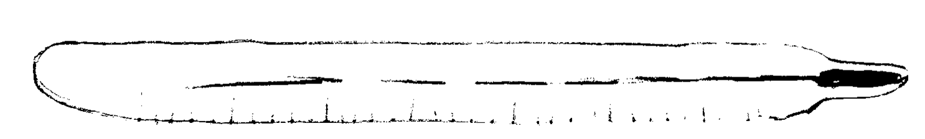
i)Have you ever seen this kind of instrument. (01mark)
………………………………………………………………………………………………………………………
………………………………………………………………………………………………………………………
ii) What is it used for. (01mark)
………………………………………………………………………………………………………………………
………………………………………………………………………………………………………………………
iii) What are its main features? (01mark)
………………………………………………………………………………………………………………………
………………………………………………………………………………………………………………………
……………………………………………………………………………………………………………………..
6) Mrs. Joan prepared tea for her sick daughter. She dipped a tea bag in hot water and the color of water changed instantly.
a) By what process did the color of water change? (02mark)
………………………………………………………………………………………………………………………
…………………………………………………………………………………………………………………..….
b) Suggest a statement that summarizes the meaning of diffusion. (02marks)
………………………………………………………………………………………………………………………
………………………………………………………………………………………………………………………
………………………………………………………………………………………………………………………

7) Mr. Alex and Mr. James applied forces of 16N and 25N on a table respectively. Find the
Resultant force if
a) They both push the table. (02marks)
………………………………………………………………………………………………………………………
………………………………………………………………………………………………………………………
………………………………………………………………………………………………………………………
b) Mr. Alex pushes and Mr. James pulls the table. (02marks)
………………………………………………………………………………………………………………………
………………………………………………………………………………………………………………………
………………………………………………………………………………………………………………………
8) (a) Is mass the same as weight? (01mark) Yes
No
b) If they are different, state two differences. (02marks)
………………………………………………………………………………………………………………………
………………………………………………………………………………………………………………………
…………….............................................................................................................................
c) Given that the acceleration due to gravity on mars is 3.77, calculate the weight of a needle of mass 300g on mars. (01mark)
………………………………………………………………………………………………………………………
………………………………………………………………………………………………………………………
………………………………………………………………………………………………………………………
………………………………………………………………………………………………………………………

9) (a) List two examples from your community, where estimation is used as a method of measurement. (02marks)

………………………………………………………………………………………………………………………
………………………………………………………………………………………………………………………
………………………………………………………………………………………………………………………
b) State two disadvantages of using estimation method of measurement. (02 marks)
………………………………………………………………………………………………………………………
………………………………………………………………………………………………………………………
……………………………………………………………………………………………………………………...

10) The diagram below shows measuring cylinder used to measure the volume of a cork
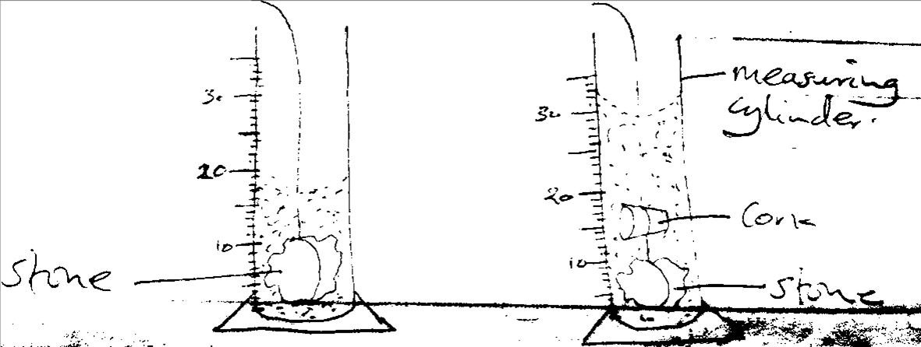

a) In which unit does it measure the volume

(01 mark)

………………………………………………………………………………………………………………………
………………………………………………………………………………………………………………………
b) What is the volume of the cork? (02 marks)
………………………………………………………………………………………………………………………
………………………………………………………………………………………………………………………
………………………………………………………………………………………………………………………
c) What are the likely sources of errors during the experiment? (01 mark)
………………………………………………………………………………………………………………………
………………………………………………………………………………………………………………………
………………………………………………………………………………………………………………….…..
END

